Documentation Assignment (Group 4)

Group Members:

Tan Wen Tao Bryan (p2214449)

Ryan Yeo (p2214452)

Zachary Leong Yao Jie (p2201861)

Ethan Jedidiah Pang Kin Fong (p2214241)

Class: DAAA/1A/01

# Task 7:

Register an account in AWS Academy and provision an Ubuntu 16.04 virtual machine. You should be able to SSH to the instance.

From this point on, the group has finished starting the AWS Instance and done the necessary configuration to be able to generate a PuTTY key.  
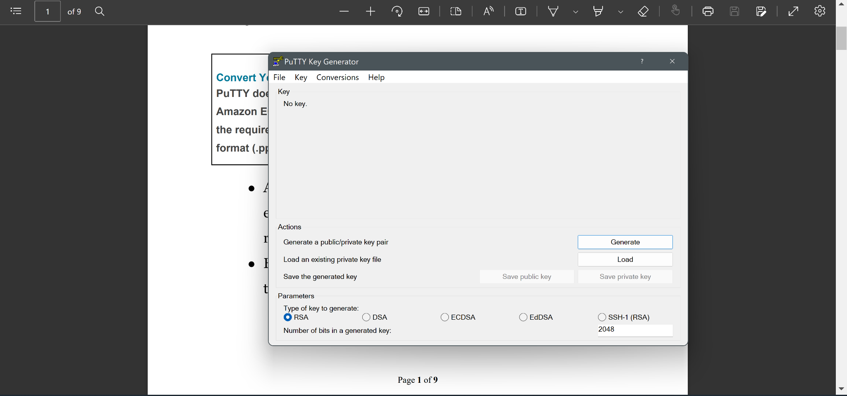

Generate a PuTTY key.

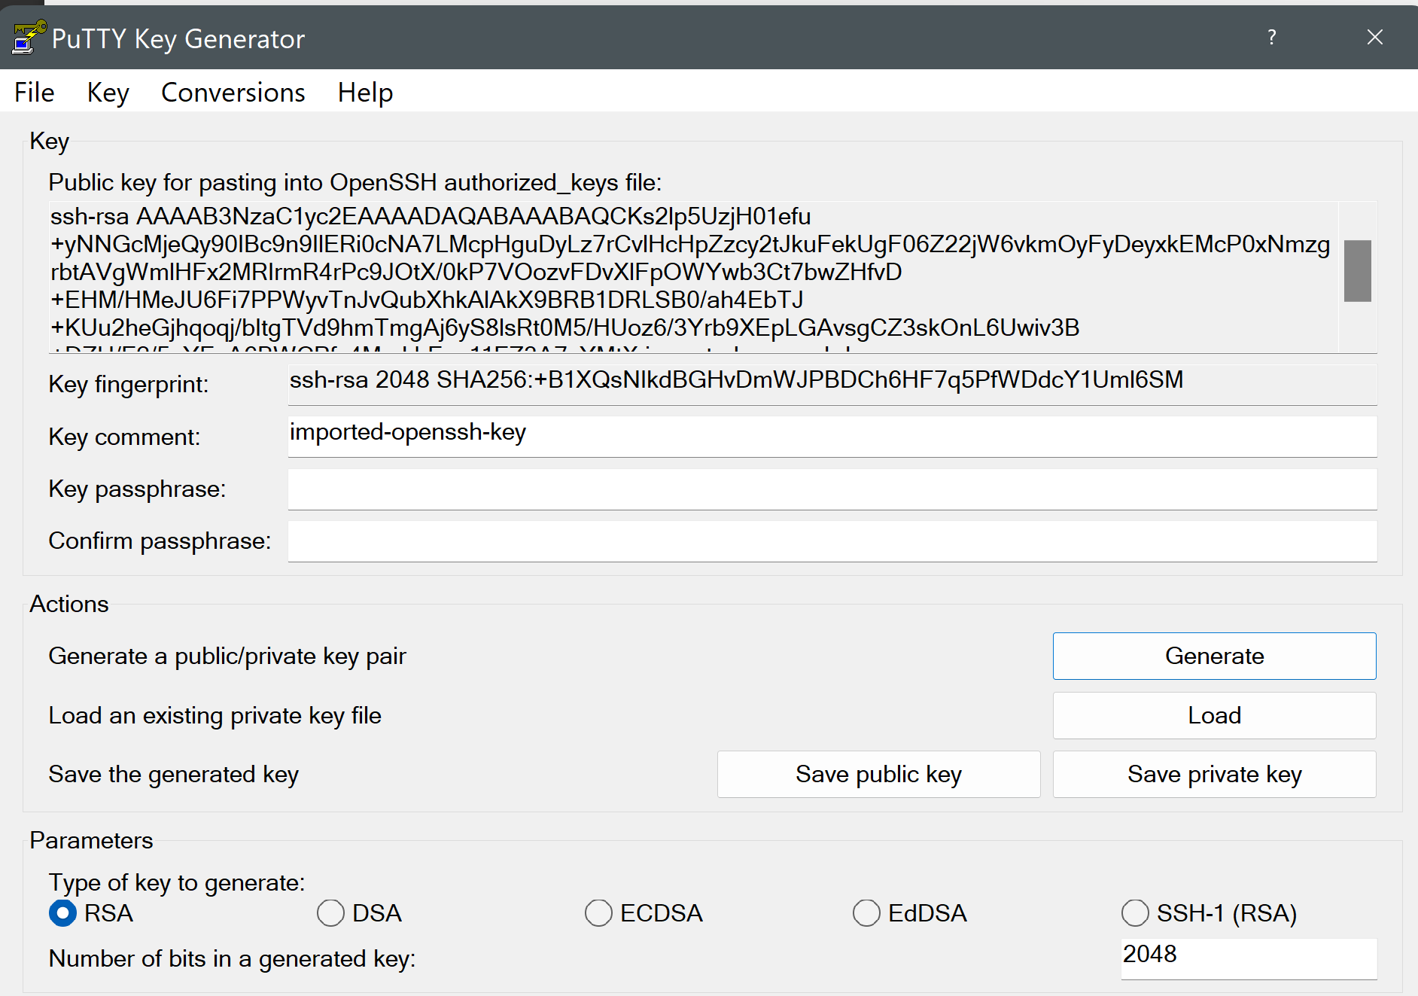

Use the elastic IP address and place it under the host name.

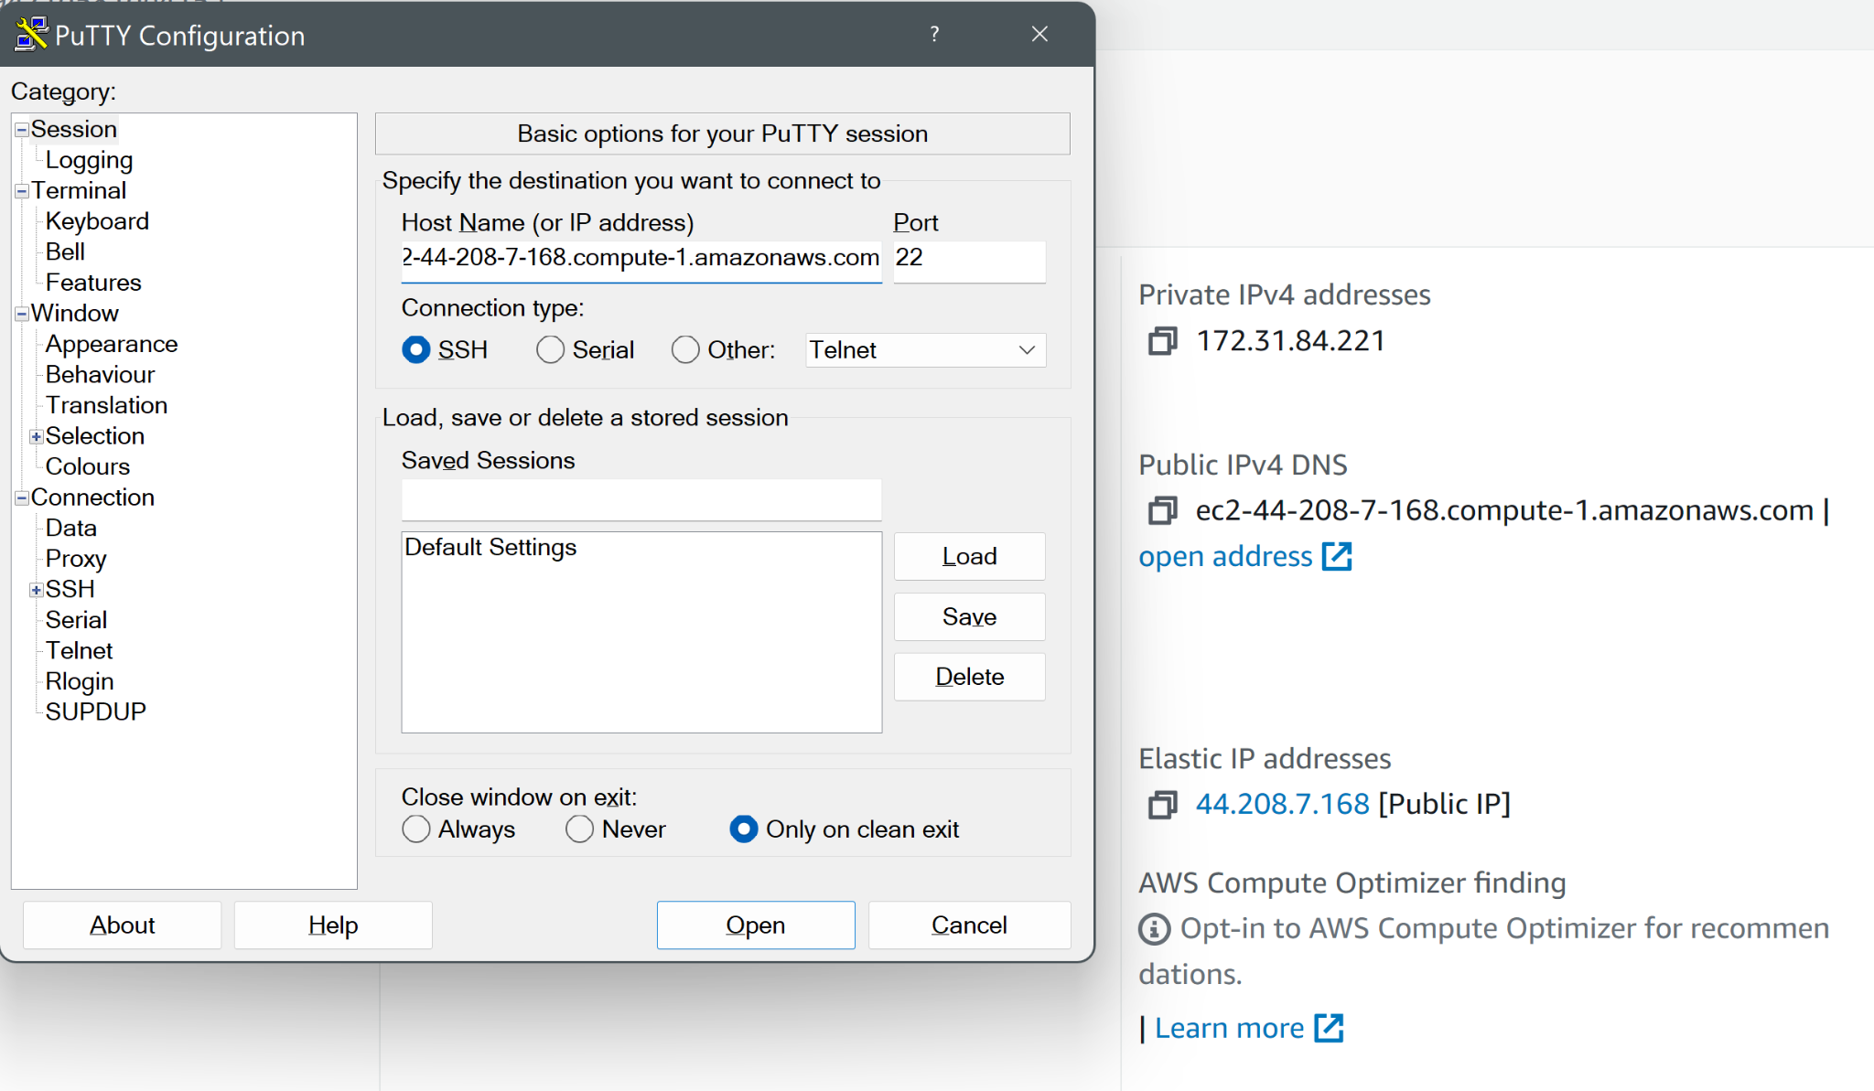

Next, save the session under Session_Group.

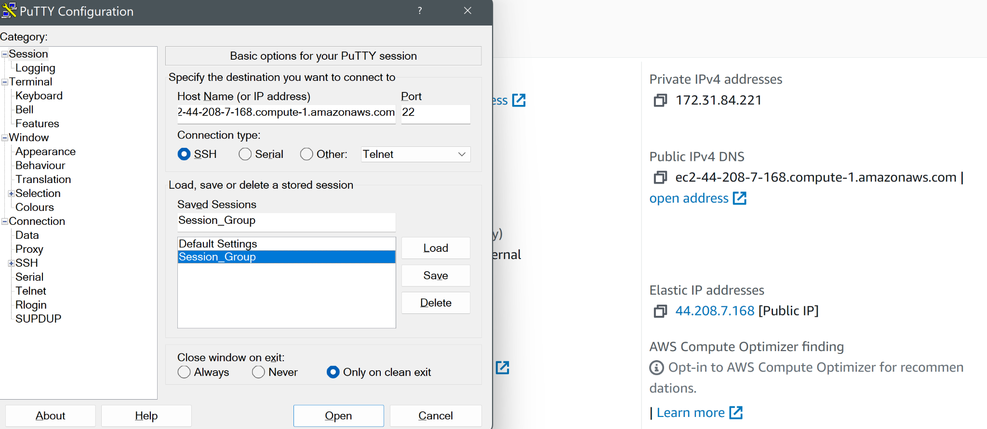

PuTTY SSH should appear like this if it successfully connected to the elastic IP.

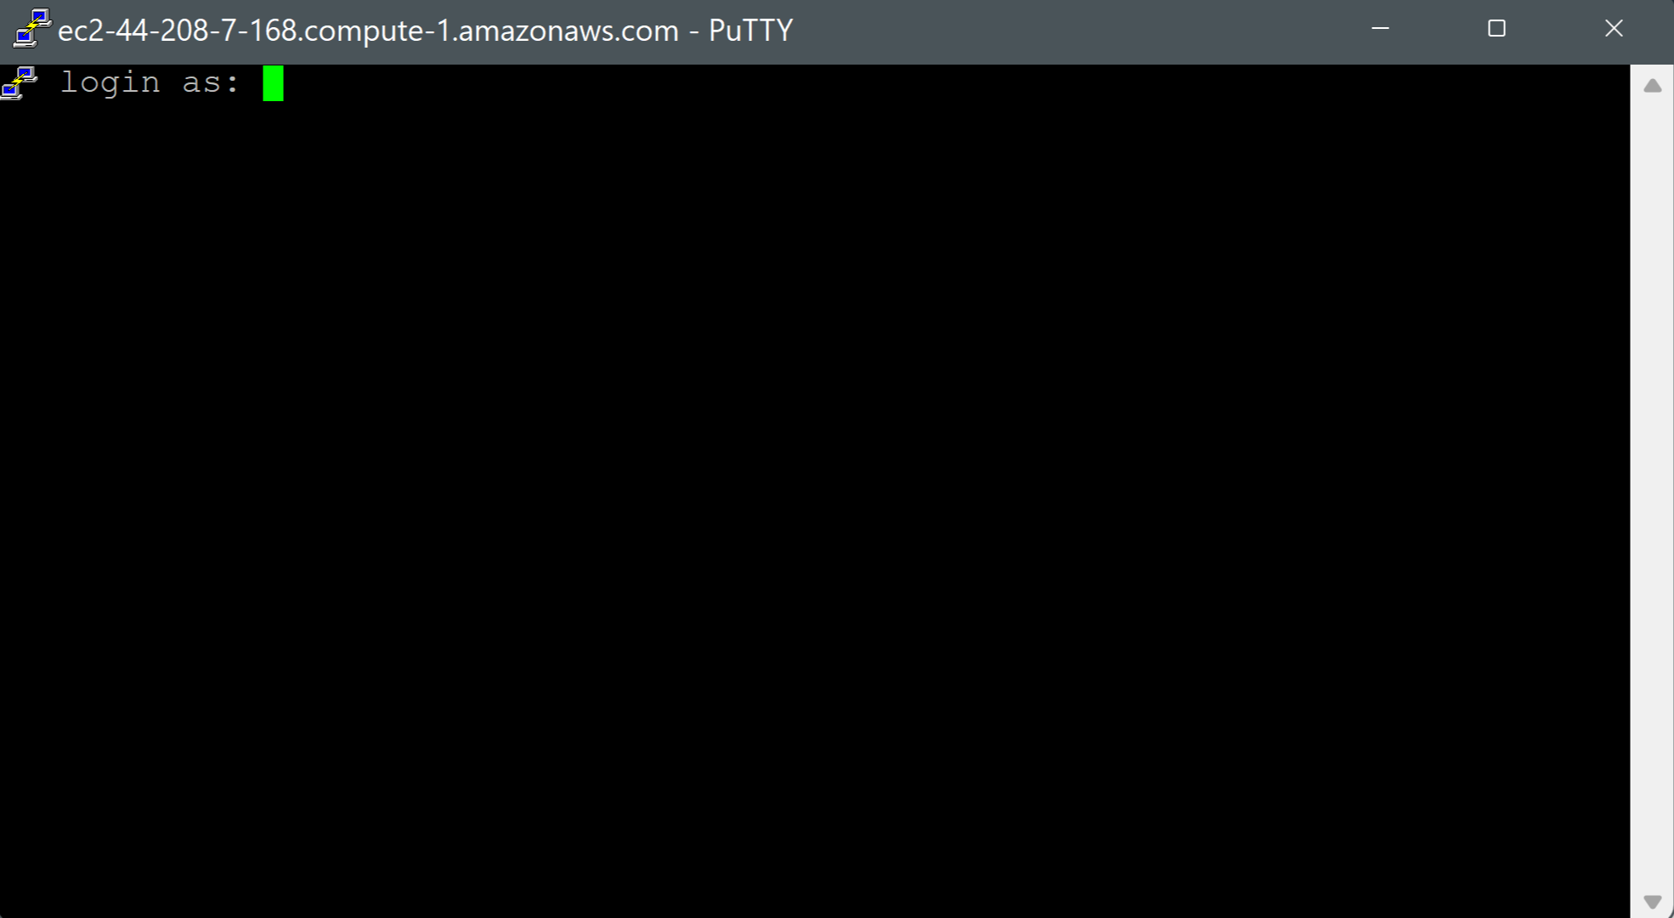

Log in as ubuntu.

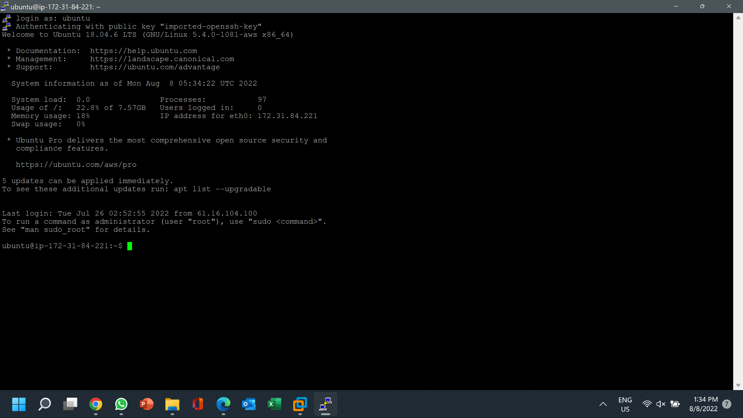

# Task 8:

Set up Apache Web Server, PHP, and MySQL server on AWS Academy instance.

**Apache**

Before installing apache, we would have to run

*sudo apt-get update*

to re-synchronize the package index files from their sources.

<https://linux.die.net/man/8/apt-get>

*sudo apt-get update doesn’t actually install new versions of software

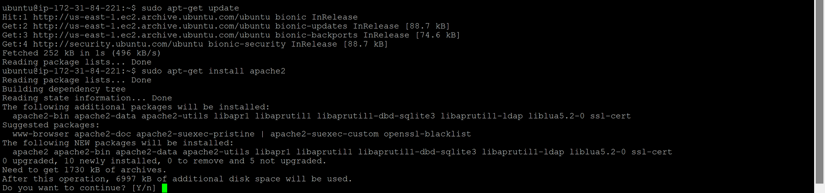

Now apache can be downloaded using

*sudo apt-get install apache2*

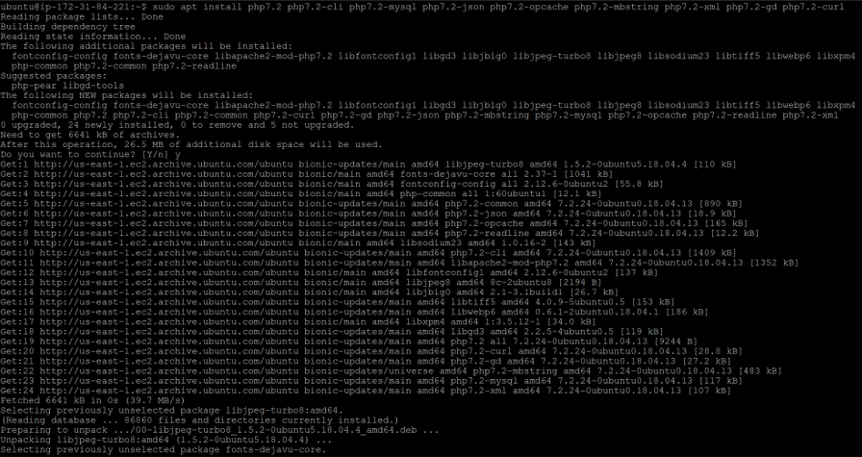

As seen by

*sudo systemctl status apache2*

apache was successfully installed

**PHP**

To install PHP, we must run

*sudo apt install php7.2 php7.2-cli php7.2-mysql php php7.2-json php7.2-opcache php7.2-mbstring php7.2-xml php7.2-gd php7.2-curl*

After this, you would have to restart apache so that the newly installed PHP extensions are loaded. This can be done with:

*sudo systemctl restart apache2*

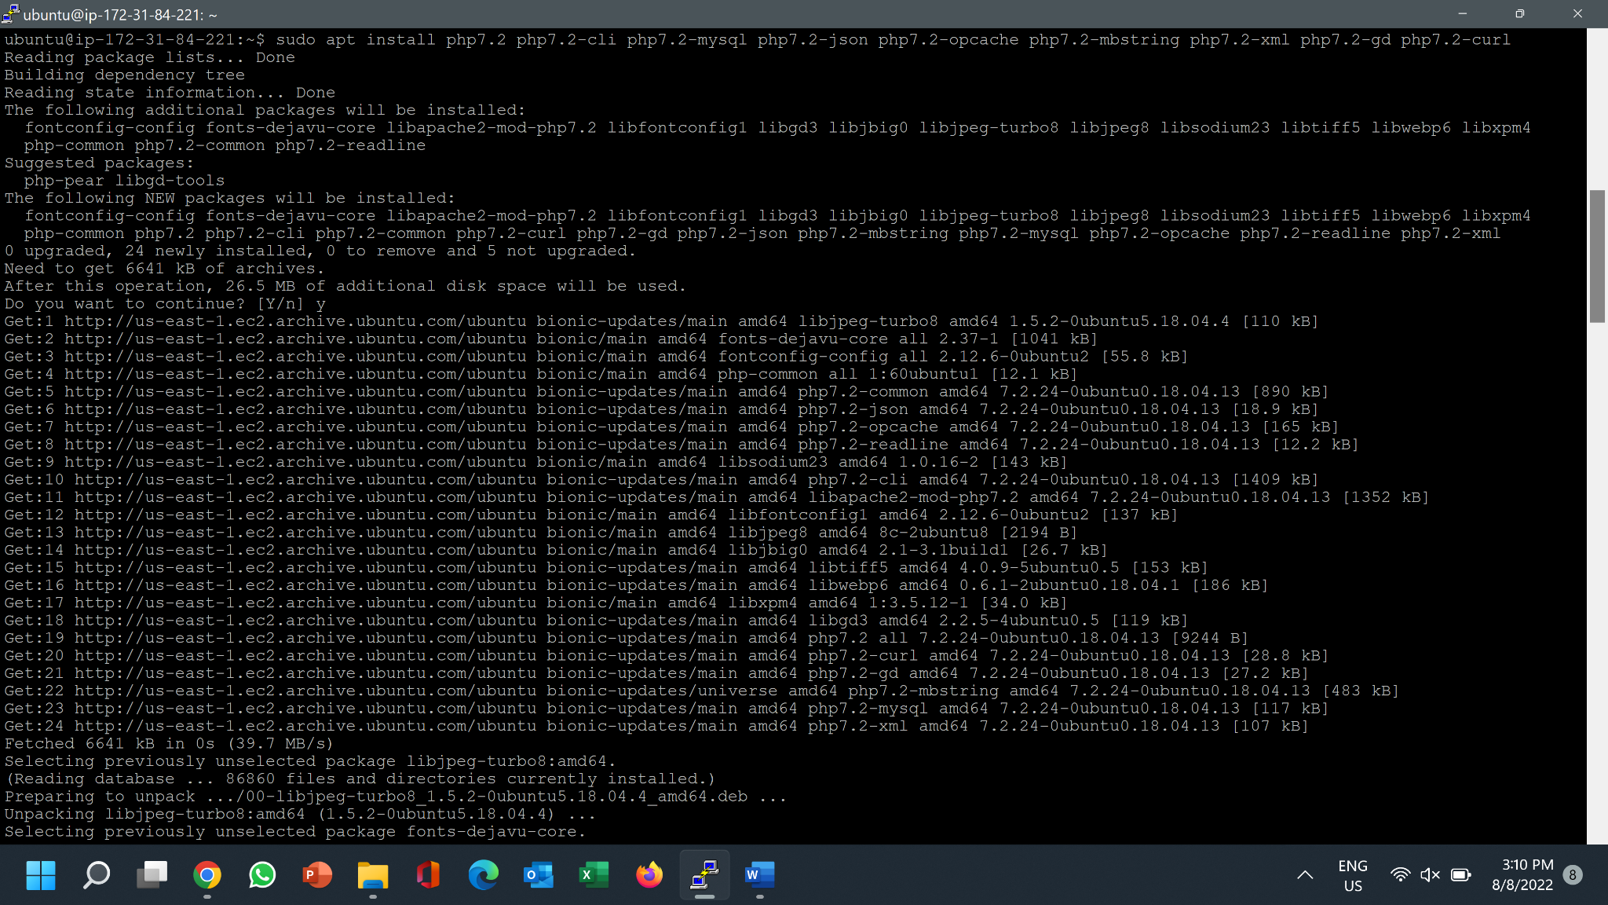

To test if php was installed correctly, we use our browser to visit

http://(elastic_ip)/test.php

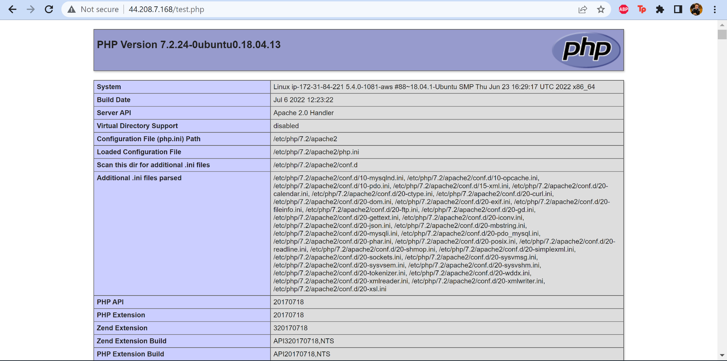

Since we can see the test page, it is successfully added.

Now we can remove test.php with

*sudo rm /var/www/html/test.php*

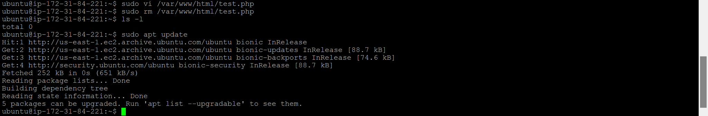

This is done for security purposes since test.php could give information about your server to unauthorized users.

**MySQL**

To install MySQL, we must run

*sudo apt install mysql-server*

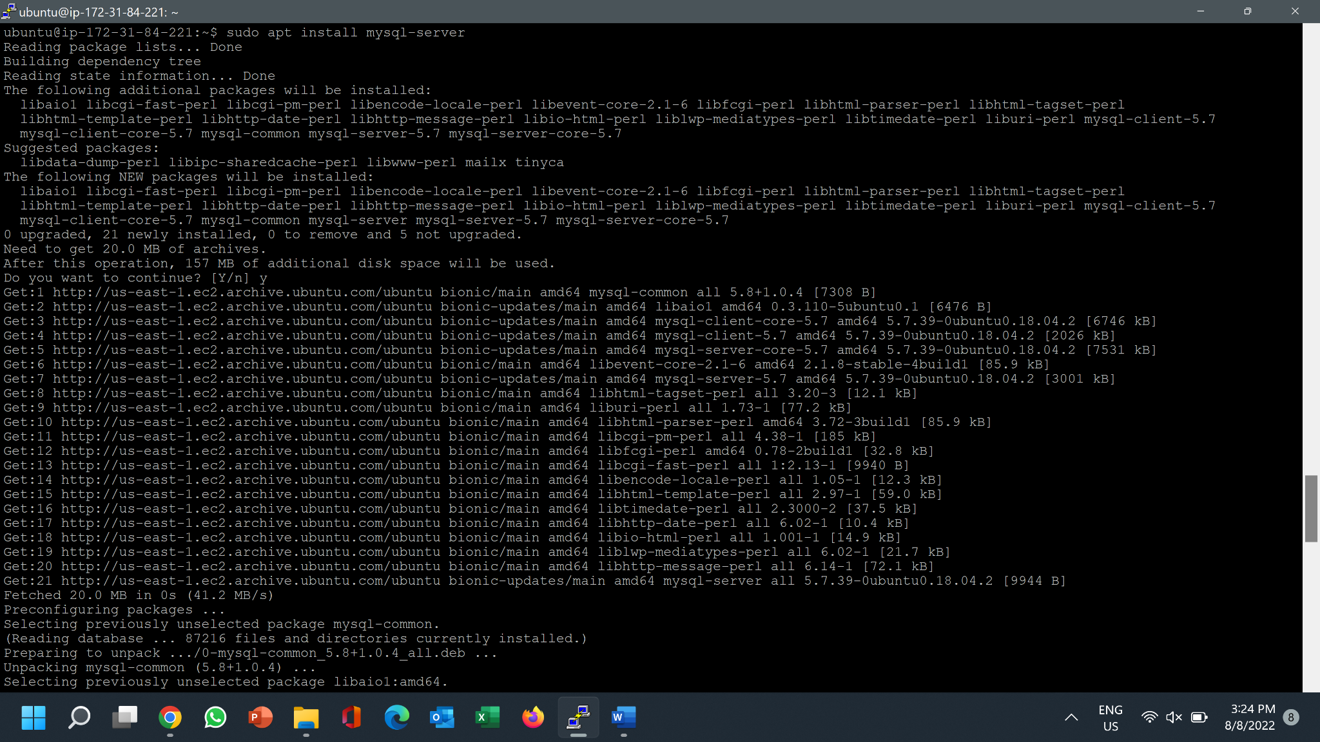

For a secure installation, we ran

*sudo mysql_secure_installation*

since it improves security by allowing us to set password for root users and remove root accounts that are accessible from outside the local host.

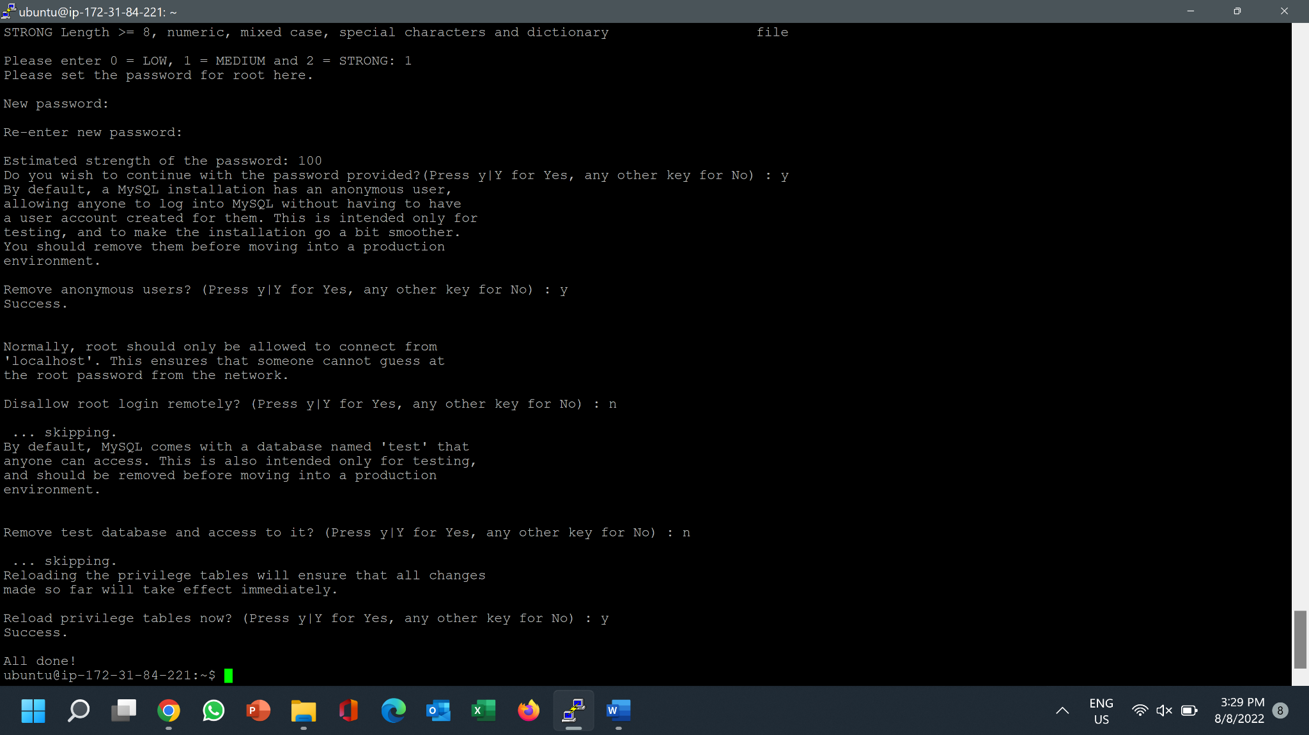

# Task 9:

Configure and manage Wordpress Web site on AWS Academy instance (similar to Wordpress Web site hosted locally on your ubuntu VM in Task 4)

**Configure MySQL**

By using

*sudo mysql*

we were then able to enter MySQL

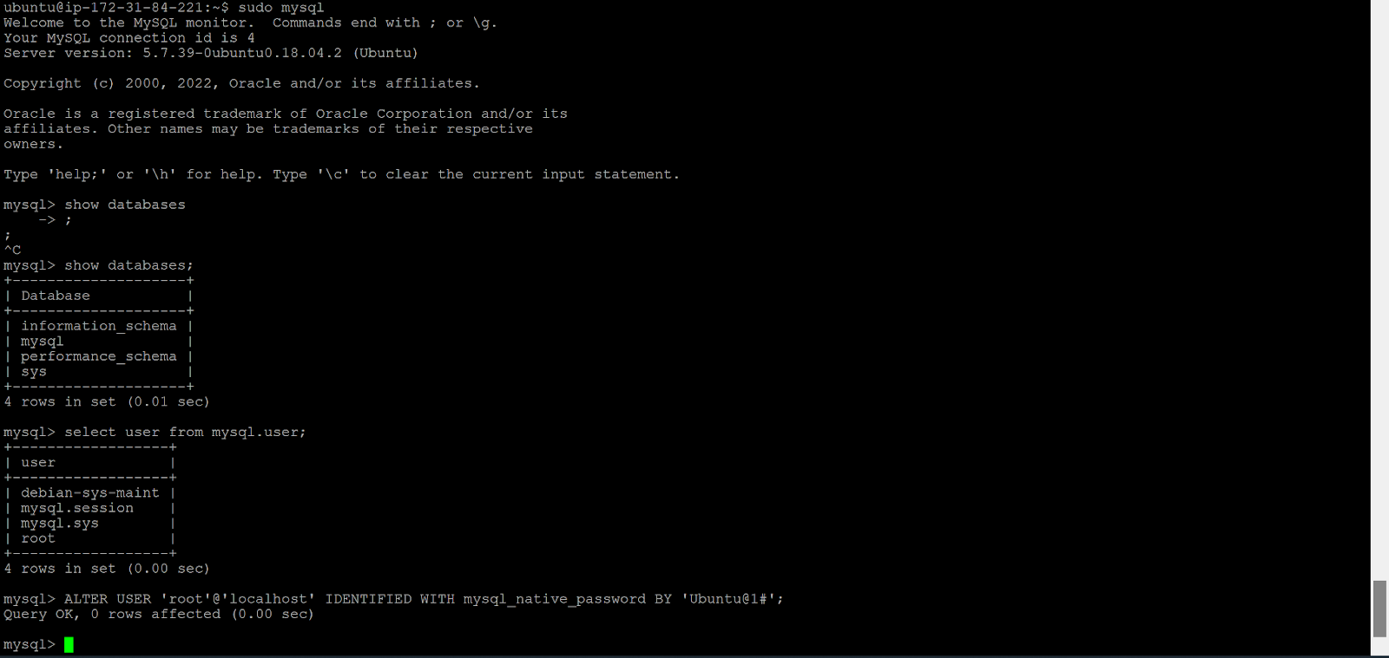

By using

*Show databases;*

And

*Select user from mysql.user;*

We can see the current users and databases inside MySQL.

We then created a new user using

*CREATE user ‘wordpress-user-p2214449’@’localhost’ IDENTIFIED BY ‘Ubuntu@1#’;*

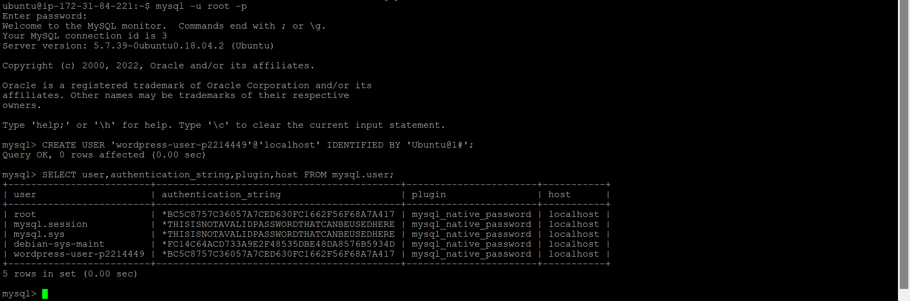

And a new database with

*CREATE database ‘wordpress-db-p2214449’;*

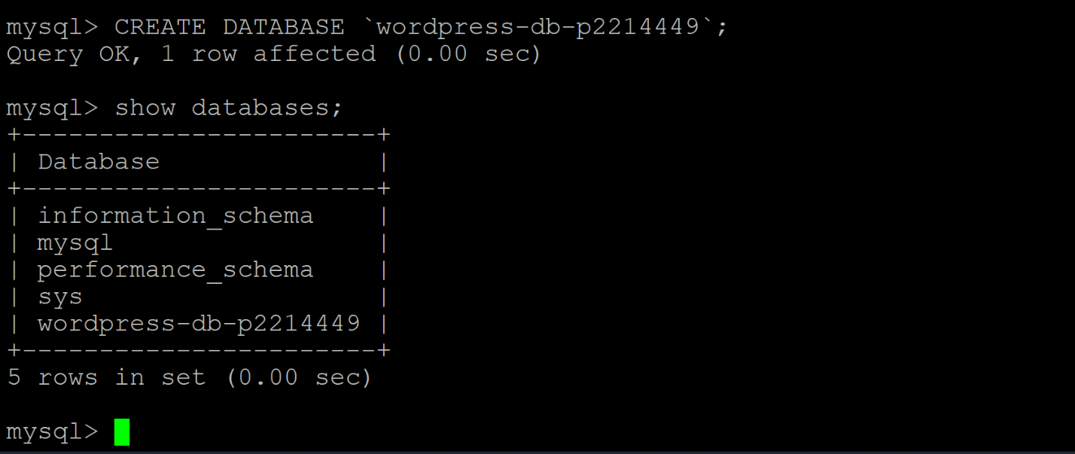

Finally, we granted privileges of the newly created database to the user before flushing privileges.



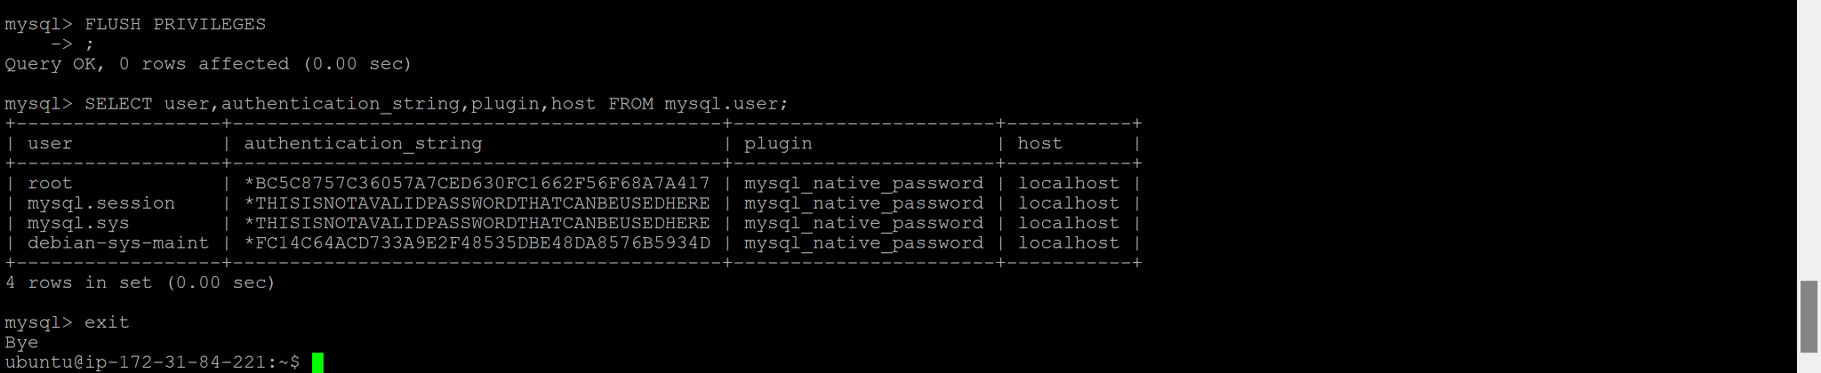

**Adding the users & groups**

Although, it was not stated to add the users and groups, our team decided to do so since we did not trust the instructions.

First, we created the two groups with

*sudo groupadd -g 10000 sysadmin*

and

*sudo groupadd -g 10100 webdev*

We can then check if both groups were sucessfully added by using

*sudo tail /etc/group*

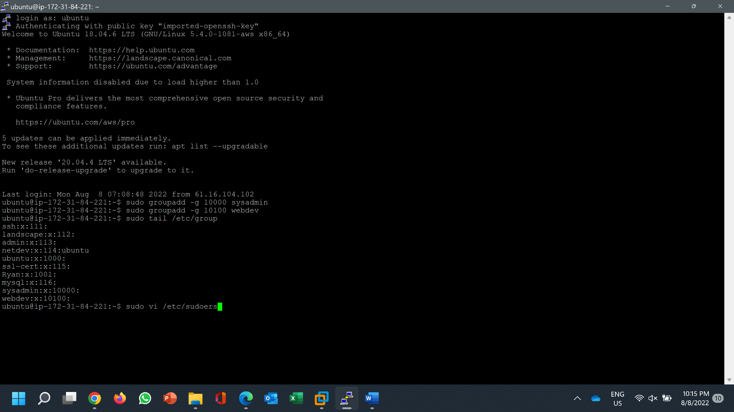

As seen above, the two groups were successfully added

In addition to using

*sudo usermod -aG sudo sysadminuser1*

*sudo usermod -aG sudo sysadminuser2*

To give the two sysadmin user rights, we deciced to edit the sudoers file using

*sudo vi /etc/sudoers*

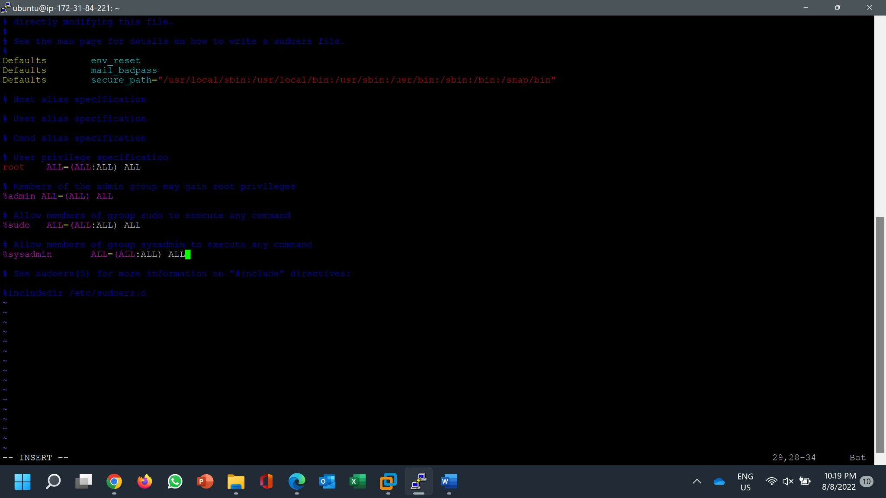

Add both system admin users using

*sudo useradd -u 442 -g 10000 -m sysadminuser1*

*sudo useradd -u 443 -g 10000 -m sysadminuser2*

where sysadminuser1 and sysadminuser2 user ids are 442 and 443 respectively and are in the same group with the group id 10000

By using

*sudo tail /etc/passwd*

we can see that the two sysadmin users were successfully added



To double check if they were added in the right groups, we used

*groups sysadminuser1*

*groups sysadminuser2*

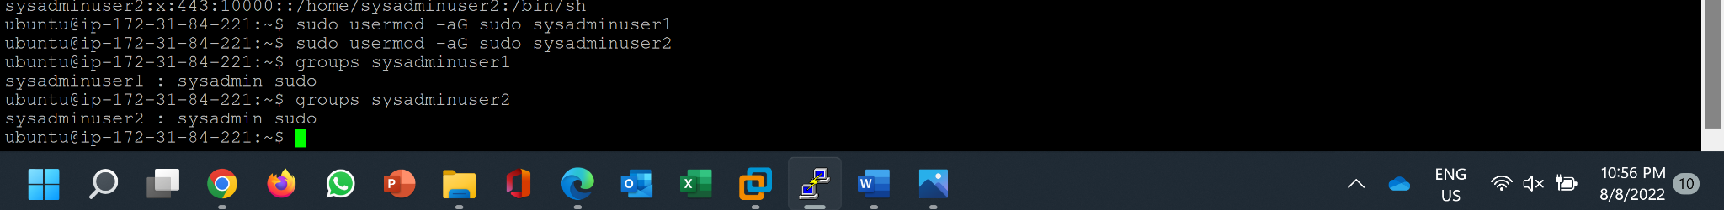

Then we added the two webdevs with

*sudo useradd -u 501 -g 10100 -m webdevuser1*

*sudo useradd -u 502 -g 10100 -m webdevuser2*

Lastly, we added passwords for all four users so that there is a reduced risk of the users being compromised.

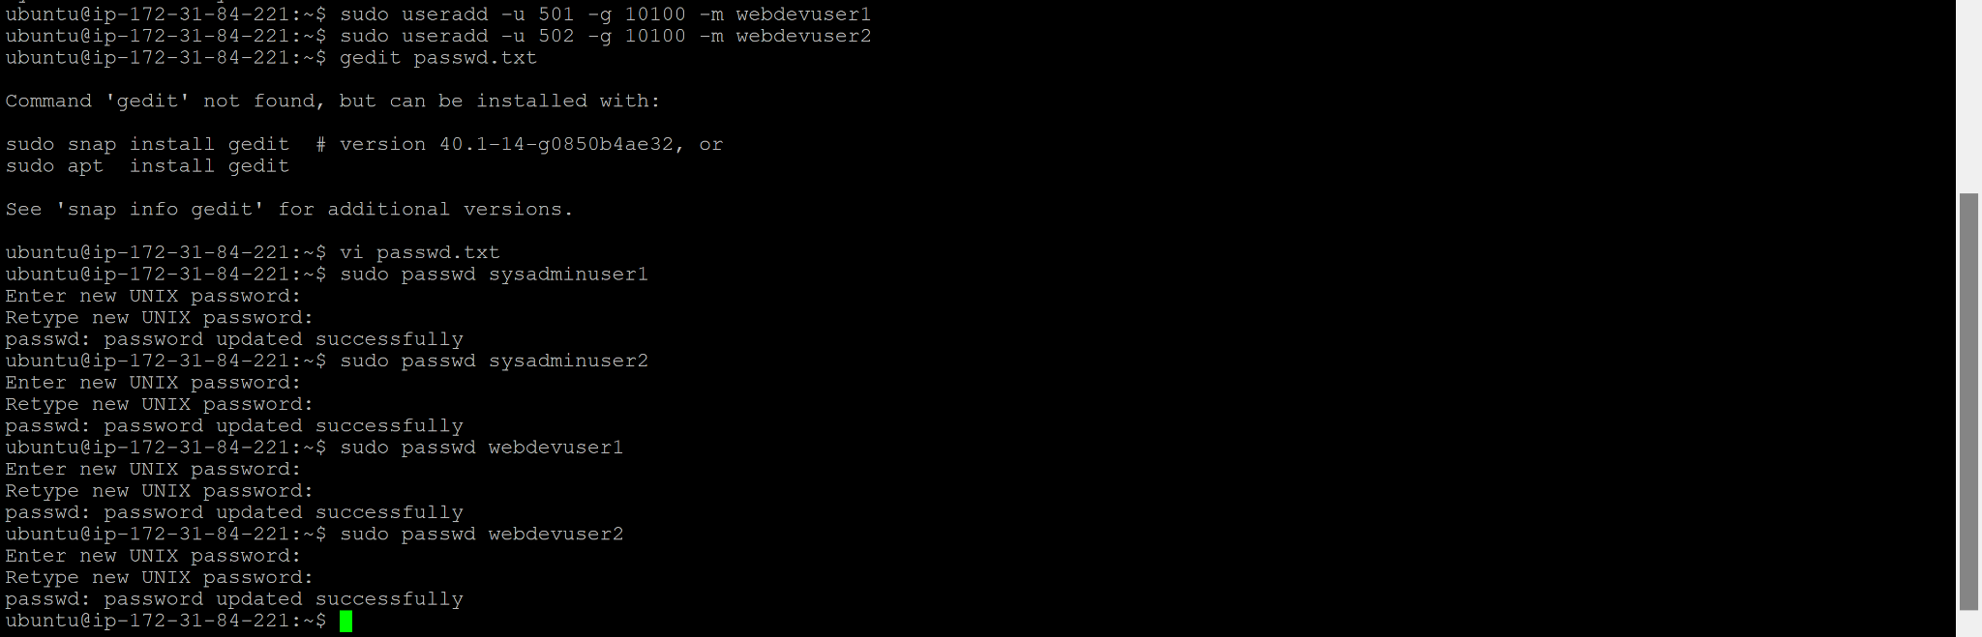

Here is a summary of the passwords for the four users:

*We only used the text file to store the passwords temporarily. We deleted this file after taking a screenshot as we did not want the password to get compromised

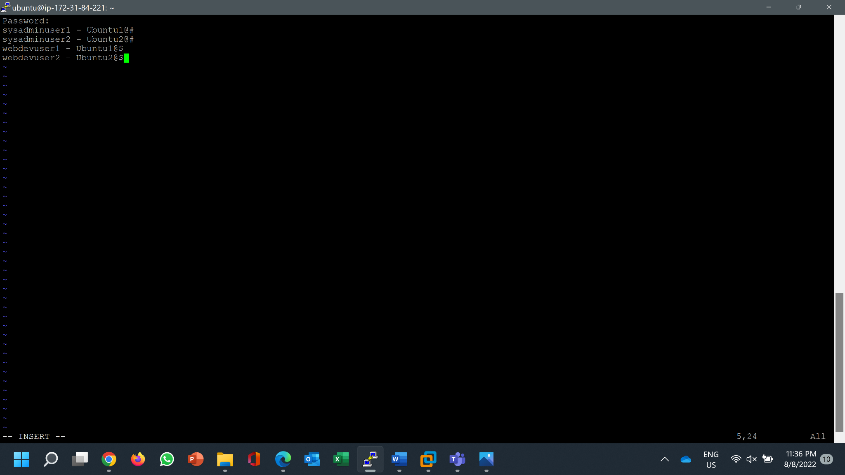

To check if sysadminuser1 and sysadminuser2 can actually start and stop servers:

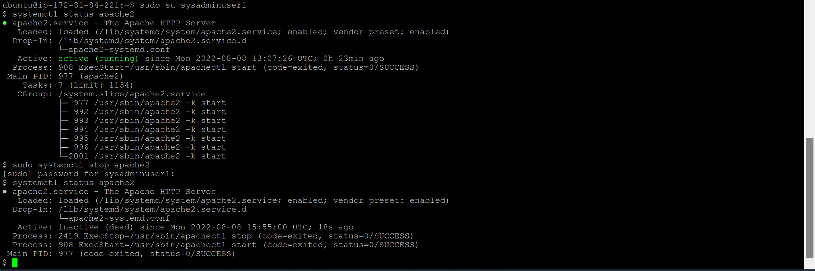

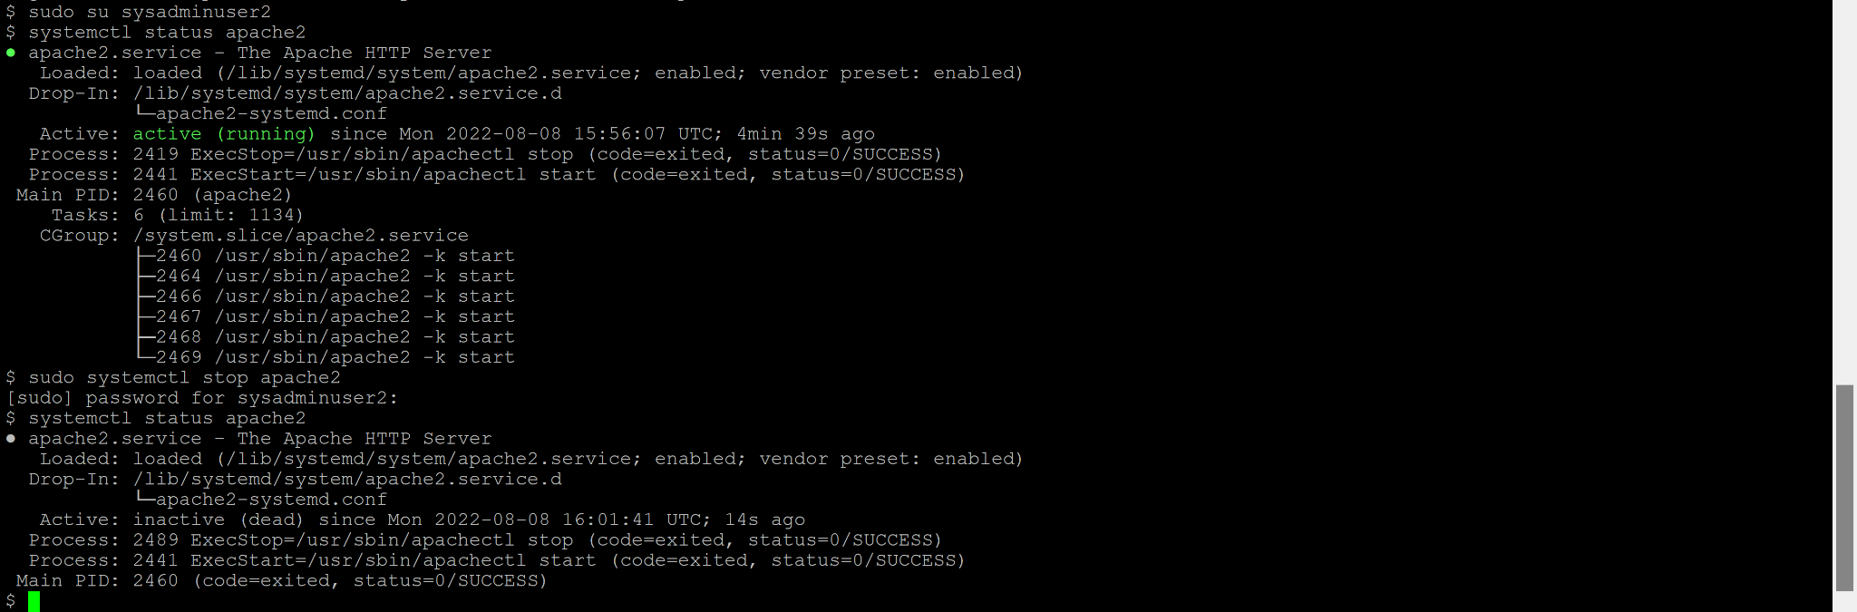

**Configure Apache Server Document Root**

First we edited the apache configuration file with

*sudo vi /etc/apache2/sites-available/000-default.conf*



*We changed the document root from

/var/www/html

To

/var/www/html/p2214449

(Increase the brightness fully to see the screenshot)

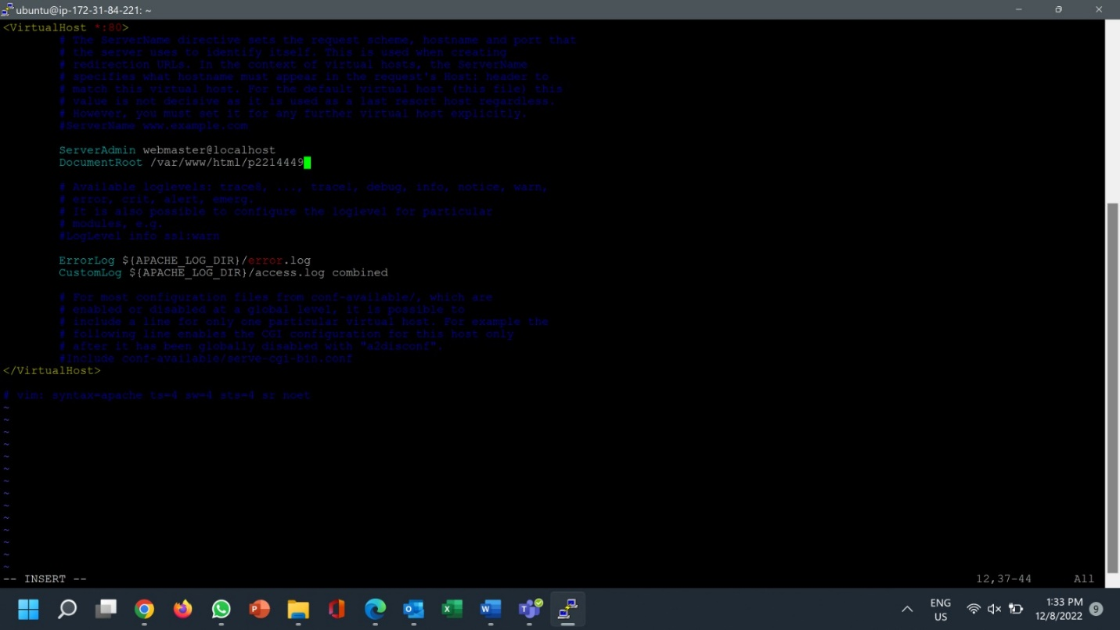

Then we created the directory to store our wordpress content (which is also our apache document root)

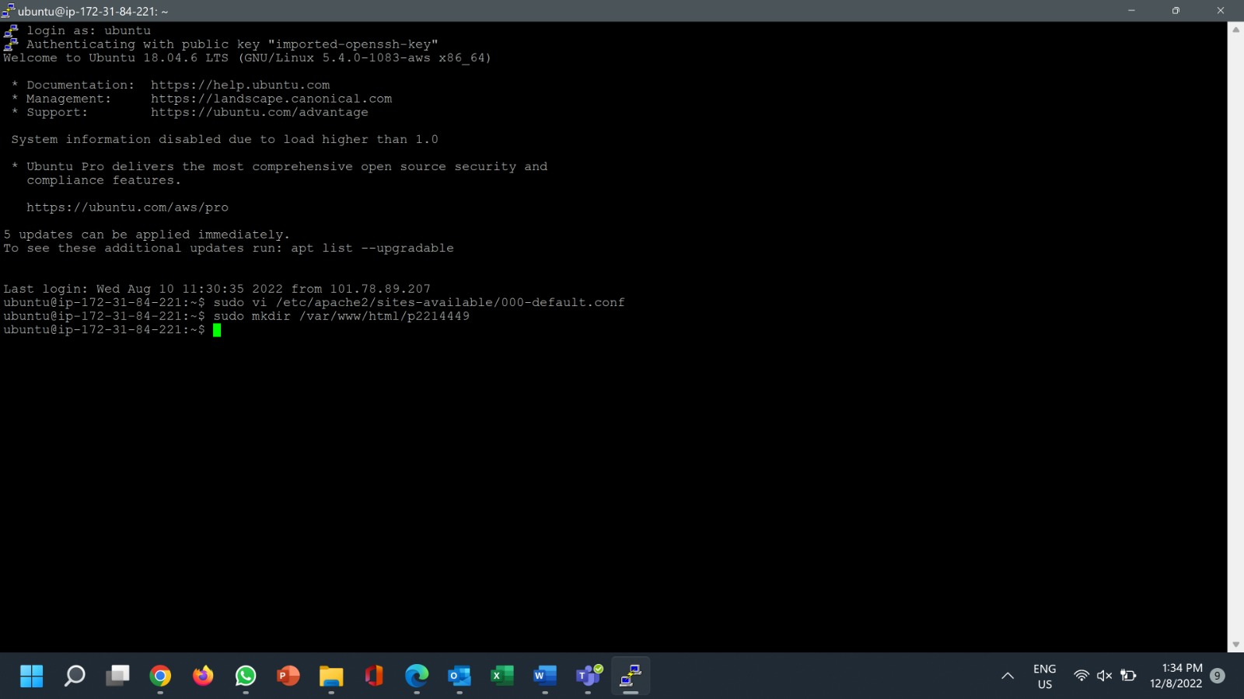

**Configure Wordpress**

We first downloaded worddpress with

*wget https://wordpress.org/latest.tar.gz*

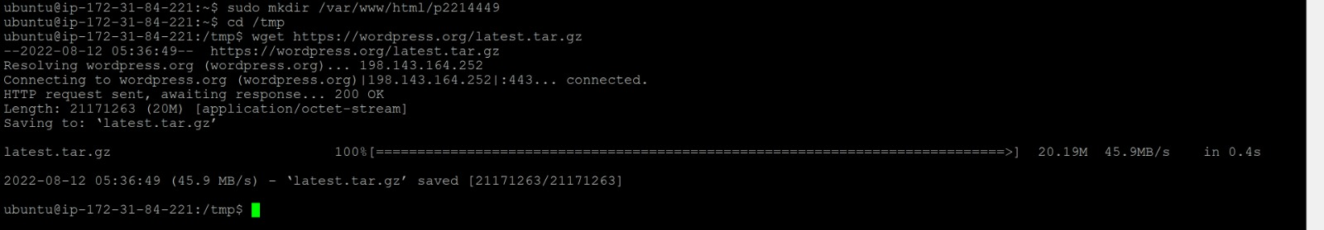

Unzip and unarchive the installation package using the command above. The installation folder is unzipped to a folder called wordpress in /tmp directory.

Verify that the WordPress contents are in /tmp/wordpress.



We copied the content from the sample php config file to create a php config file



We added the db name, user and password inside the wp-config.php file.

(Increase the brightness fully to see the screenshot)

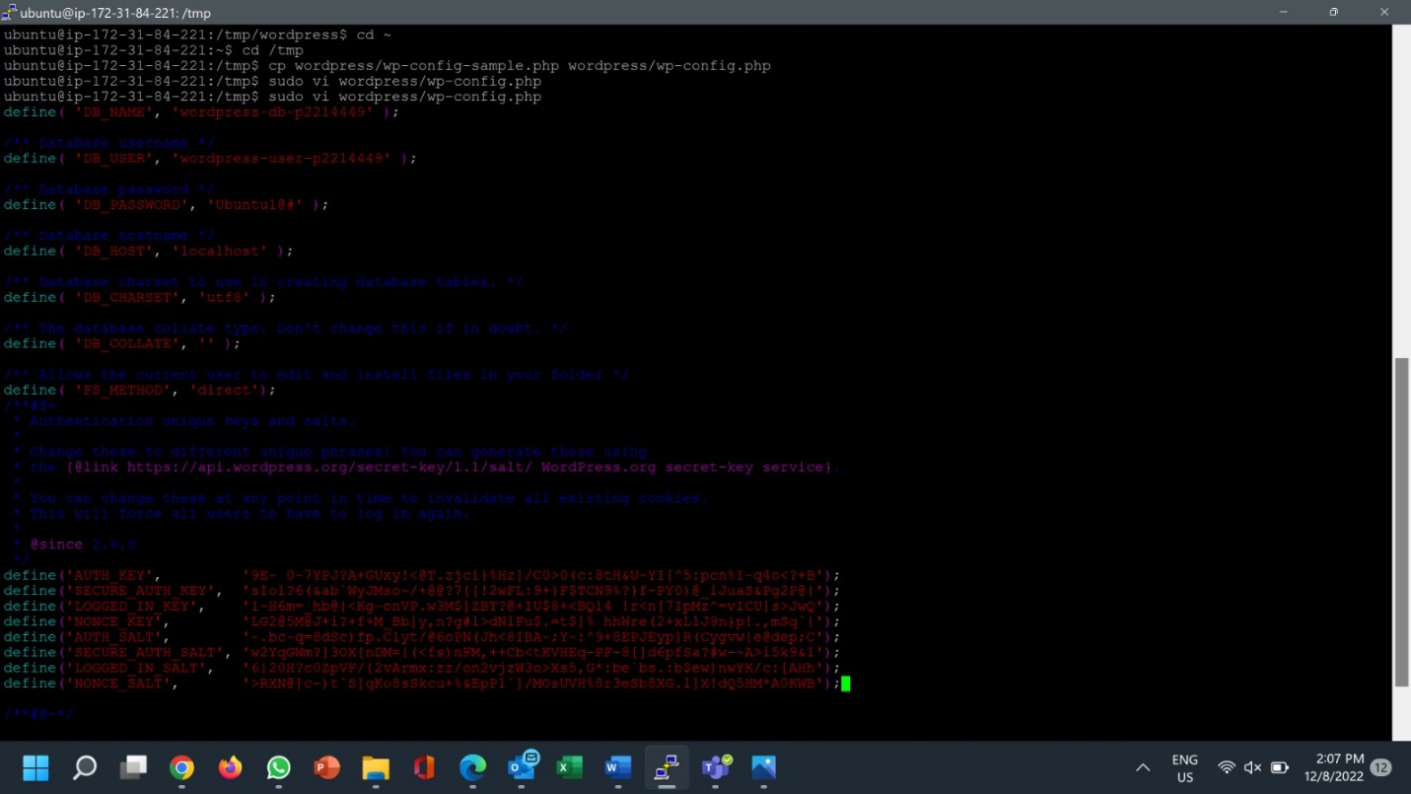

Finally, we copied the content from WordPress into our previously prepared directory.

Owners of directories are changed.



By giving

*sudo chown -R www-data:webdev /var/www*

we made www-data the owner and webdev the group in charge

Using

*sudo find /var/www – type d -exec sudo chmod 2775 {} \;*

and

*sudo find /var/www – type f -exec sudo chmod 0664 {} \;*

we managed to change the rights of the directories and files inside /var/www for www-data.

Restart apache web server and mysql server to apply the changes.



Users can now access the group’s website via its elastic IP address in the browser.

Troubleshooting

Issue: Unable to connect to apache web server as IP address is dynamic and the security rule only allows connection through SSH as stated below.

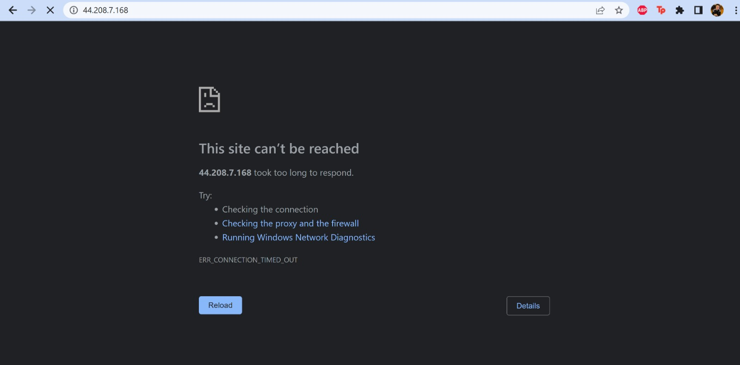

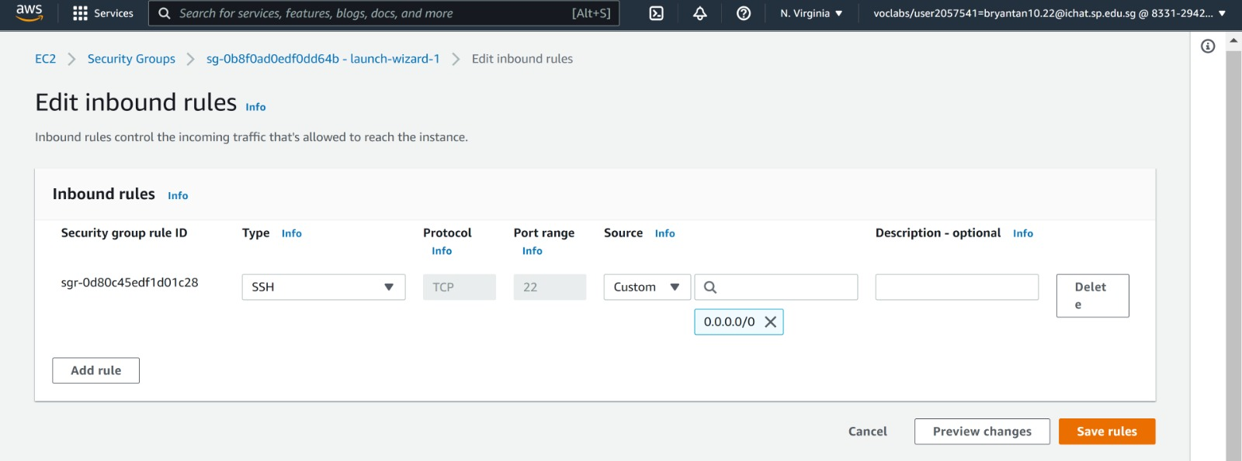

Solution: Add the new security rules which allows connection to http and https.

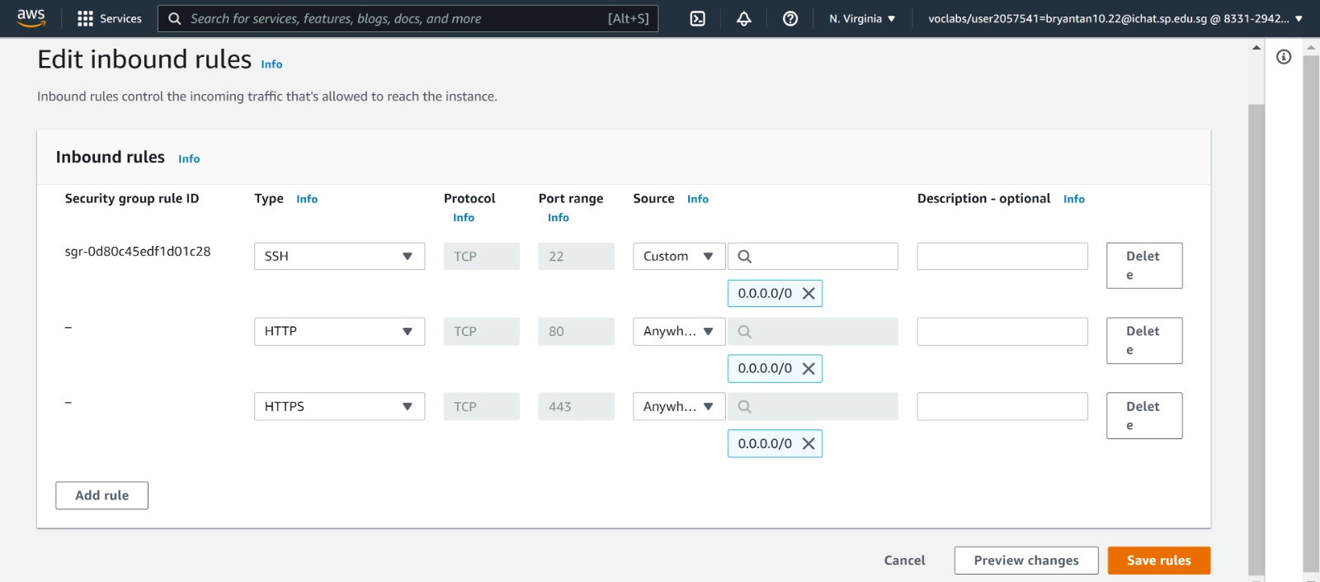

Result: Apache default page can now be seen as server now is connected to http and https can be accessed through the elastic IP address.

